ASSIGNMENT 2

|  |  |
| --- | --- |
| Date | 23 November 2022 |
| Name | Abisha.G |
| Reg no | 962219104004 |
| Maximum marks | 2 Marks |

# 1)ass2.html

<!DOCTYPE html>

<html>

<head>

<title>Assignment 2</title>

<style> td { line-height: 2.1;

}

</style>

</head>

<body>

<center>

<h3>ASSIGNMENT 2</h3>

<form action = "/login" method = "post">

<table>

<tr><th></th><th></th></tr>

<tr>

<td><label> Name : </label></td>

<td><input type="text" name="name" placeholder="Enter Name" required ></td></tr> <tr>

<td><label> Email : </label></td>

<td><input type="email" name="email" placeholder="Enter Email" required></td></tr> <tr>

<td><label> Phone No : </label></td>

<td><input type=”number" name="no" placeholder="Enter Phone No " required></td></tr>

<tr><td colspan=2>

<center>

<input type="submit" name="submit"></center></td></tr>

</form>

</table>

</center>

</body>

</html>

# ass21.html

<!DOCTYPE html>

<html>

<head>

<title>Assignment 2</title>

<style> td { line-height: 2.1;

}

</style>

</head>

<body>

<center>

<h3>ASSIGNMENT 2</h3>

<form action = "/login" method = "post">

<table>

<tr><td> Name : <b>{{y}}</b></td></tr>

<tr><td> Email : <b>{{x}}</b></td></tr>

<tr><td> Phone No: <b>{{z}}</b></td></tr>

</table></form>

</center>

</body> </html> **ass2.py**

from flask import Flask,render_template,request app = Flask(__name__,template_folder = 'template') @app.route('/') def home():

return render_template('ass2.html') @app.route('/login' , methods = ["POST"]) def login(): if request.method == "POST": n=request.form.get('name') e=request.form.get('email') p=request.form.get('pass') return render_template("ass21.html",y=n,x=e,z=p) if __name__=='__main__': app.run(debug = True)

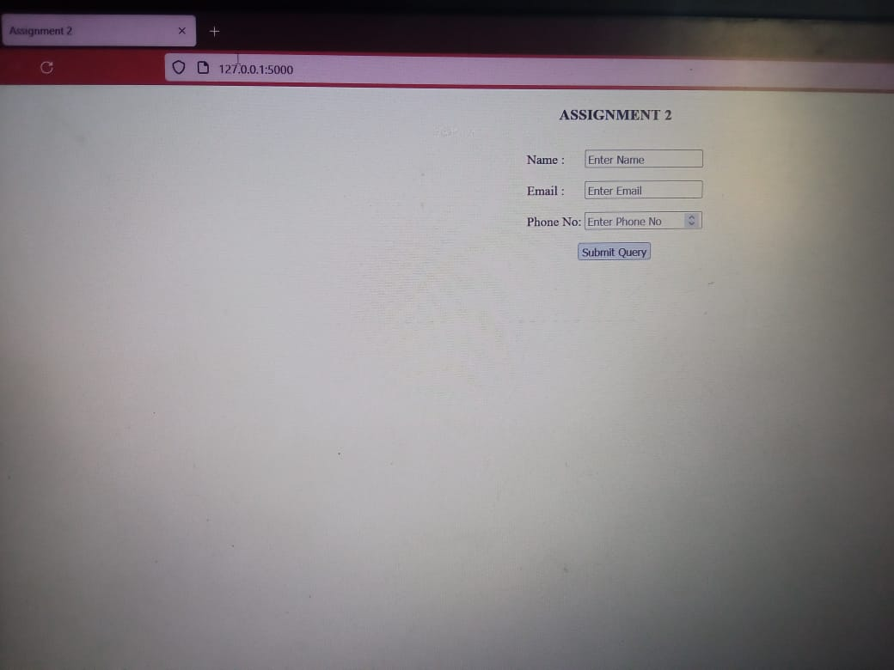

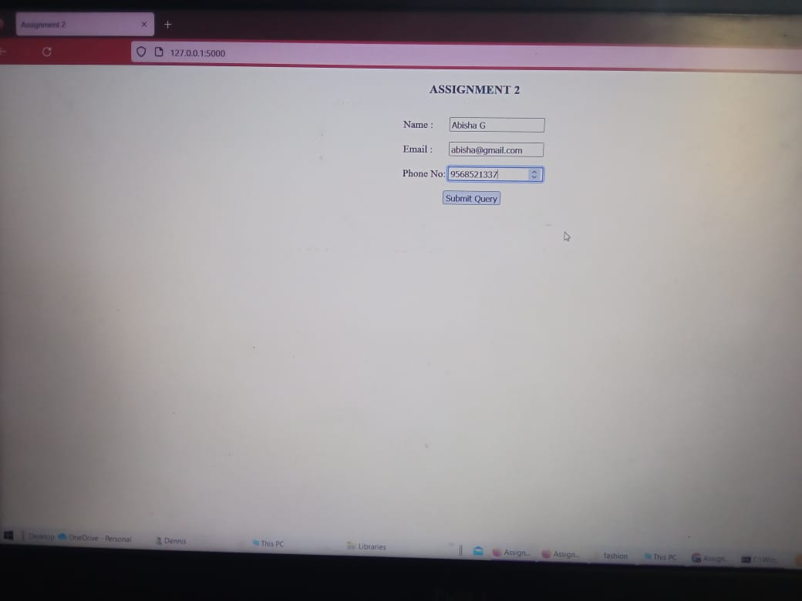

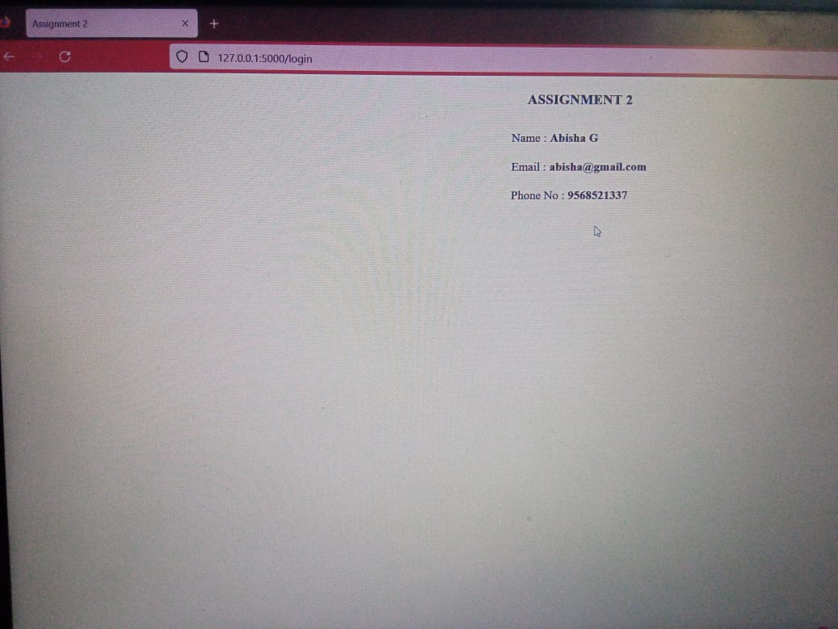

# 2)ass2cke.py

from flask import * app = Flask(__name__) @app.route('/') def keys():

res = make_response("Cookie was inserted successfully :)") res.set_cookie('IBM','Assignment2') return res

if __name__=='__main__': app.run(debug = True)

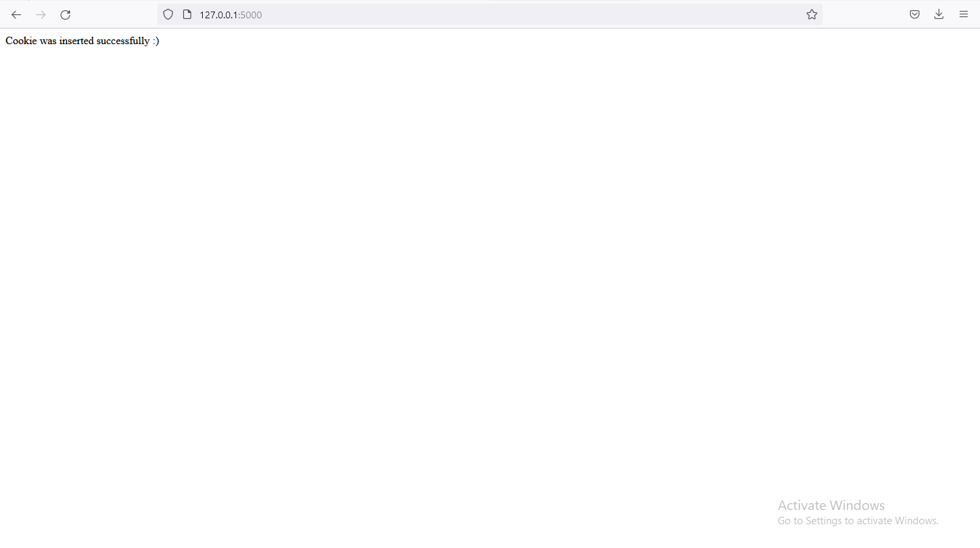

# index.html

{% extends "layout.html" %}

{% block y %}

{% if session.name %}

<br><b>

<center>You are Register {{ session.name }} <a href="/logout">logout</a>.</center> {% else %}

<center>You are not Register. <a href="/login">login</a>.</center>

</b>

{% endif %}

{% endblock %}

# login.html

{% extends "layout.html" %}

{% block y %}

<center>

<h3> REGISTER </h3>

<form action="/login" method="POST">

<input placeholder="Enter Name" autocomplete="off" type="text" name="name">

<input type="submit" name="Register">

</form>

</center>

{% endblock %}

# layout.html

<!DOCTYPE html>

<html lang="en">

<head>

<meta name="viewport" content="initial-scale=1, width=device-width">

<title> flask </title>

</head>

<body>

{% block y %}{% endblock %}

</body>

</html>

# ass2sess.py

from flask import Flask, render_template, redirect, request, session

# The Session instance is not used for direct access, you should always use flask.session from flask_session import Session

app = Flask(__name__,template_folder = 'template') app.config["SESSION_PERMANENT"] = False app.config["SESSION_TYPE"] = "filesystem"

Session(app)

@app.route("/") def index(): if not session.get("name"): return redirect("/login") return render_template('index.html') @app.route("/login", methods=["POST", "GET"]) def login():

if request.method == "POST":

session["name"] = request.form.get("name") return redirect("/")

return render_template("login.html")

@app.route("/logout") def logout():

session["name"] = None return redirect("/") if __name__ == "__main__":

app.run(debug=True)

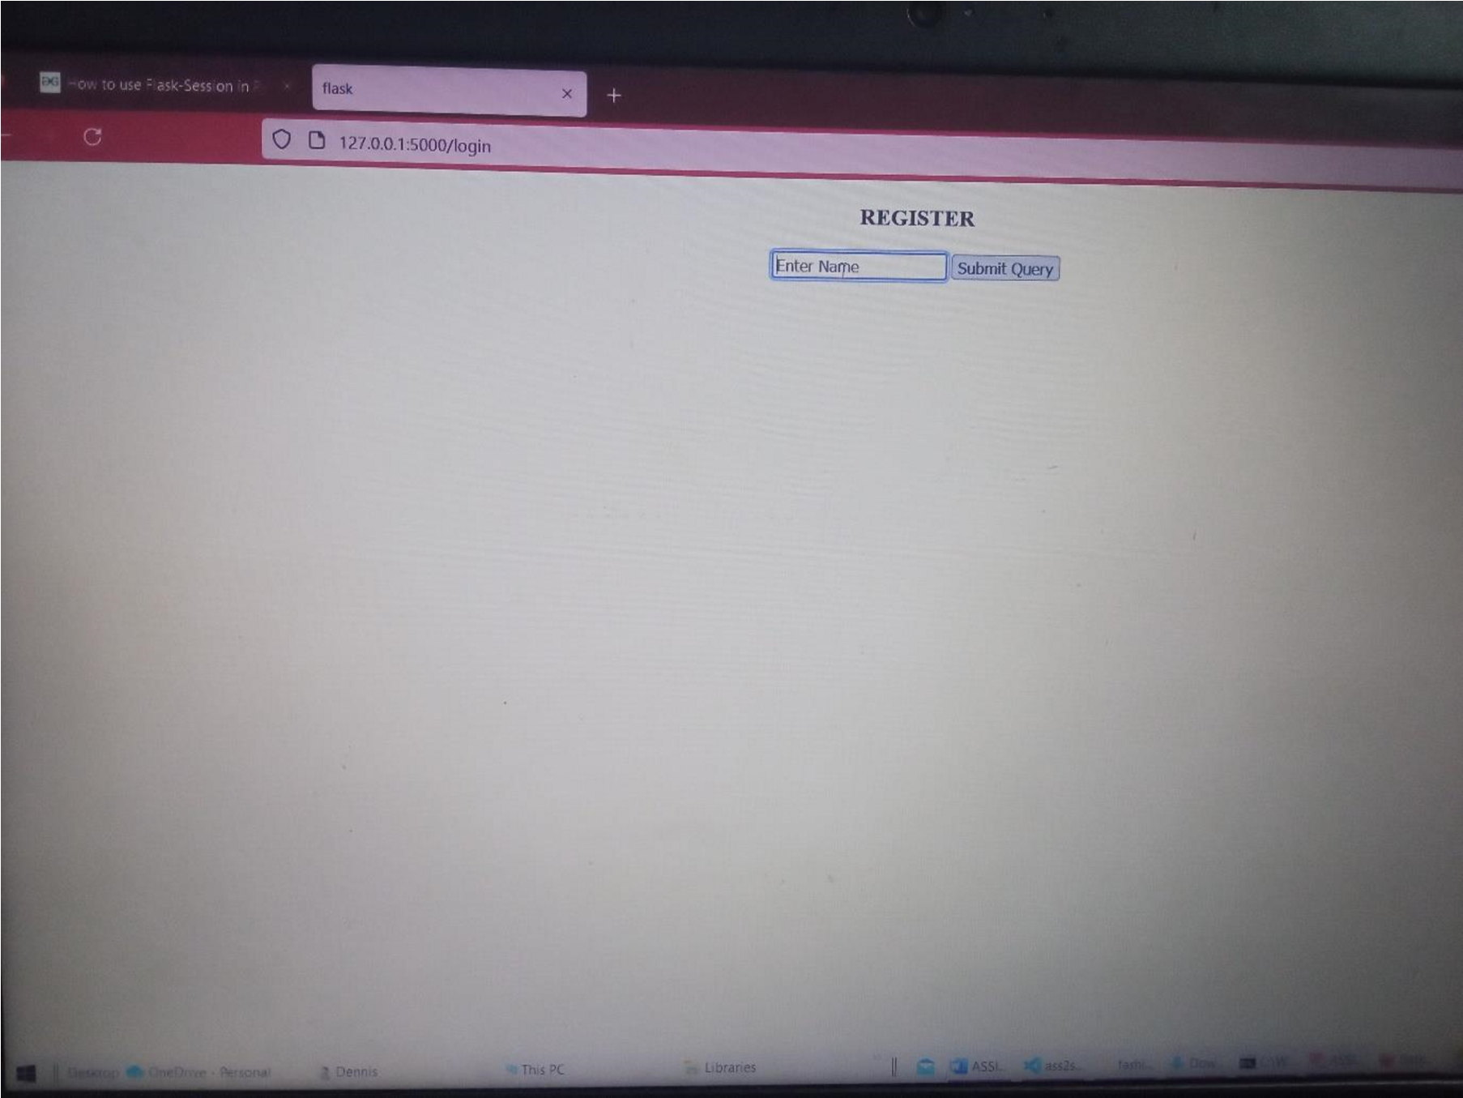

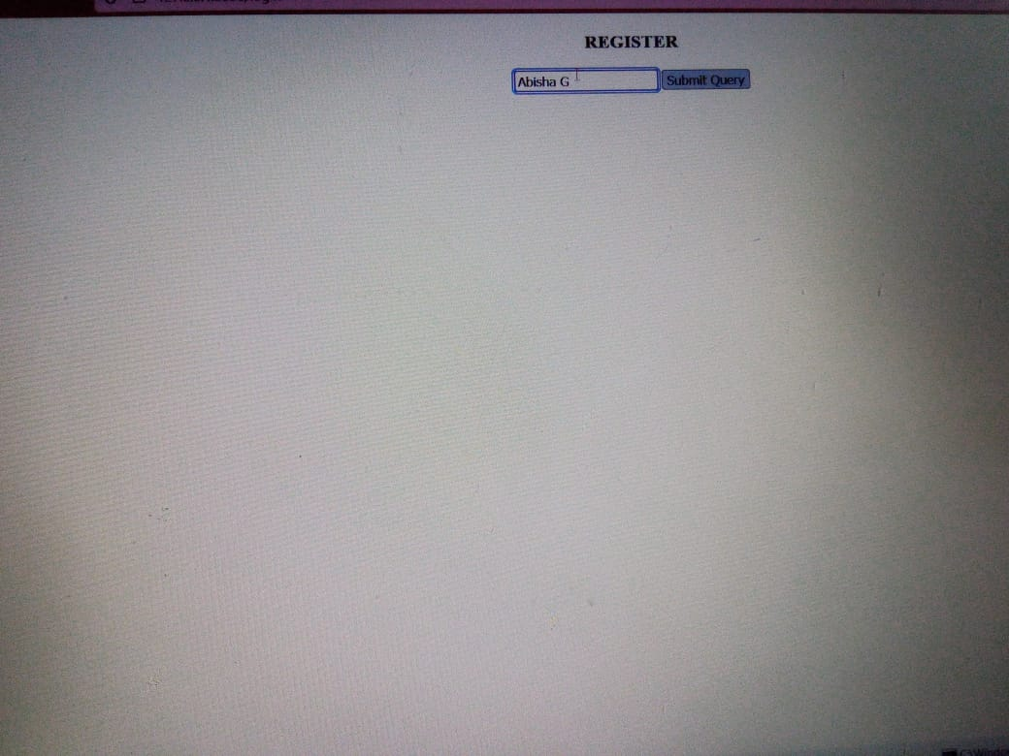

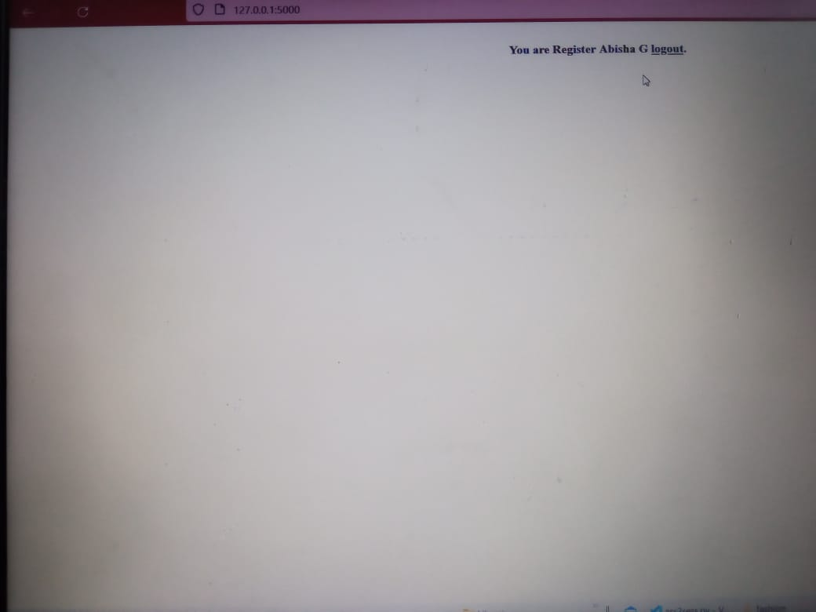

# 3)ass23.html

<!DOCTYPE html>

<html>

<head>

<title>Assignment 2</title>

<style>

tr {

line-height: 2.1;

}

</style>

</head>

<body>

<center>

<h3>ASSIGNMENT 2<br><br>FILE UPLOAD - RESUME</h3>

<div>

<form action ="/upload" method="POST" enctype ="multipart/form-data">

<b><label>Upload the Resume</label><br><br></b>

<input type ="file" name ="file"/>

<input type ="submit" value="Save"/>

</div>

<div>

<form action = "/upload" method = "post">

<table>

<tr><th></th><th></th></tr>

<tr><td><label> Name : </label></td>

<td><input type="text" name="name" placeholder="Enter

Name" required ></td></tr>

<td><label> Date of Birth : </label></td>

<td><input type="date" name="dob" placeholder="Enter DOB" required></td></tr>

<tr><td><label> Email : </label></td>

<td><input type="text" name="email" placeholder="Enter Email" required></td></tr>

<tr><td><label> College Name

:&emsp;&emsp;&emsp;</label></td>

<td><input type="text" name="clg" placeholder="Enter College Name" required></td></tr>

<tr>

<td><label>Qualification</label></td>

<td><select id="qua" name="deg">

<option value="none" selected disabled hidden>Select the Degree</option>

<option value="B.E">B.E</option>

<option value="B.Tech">B.Tech</option>

<option value="B.Sc">B.Sc</option>

<option value="B.A">B.A</option></select></td></tr>

<td><label> CGPA in %: </label></td>

<td><input type="number" length="2" name="cgpa" placeholder="Enter CGPA" required></td></tr>

<td><label> Year : </label></td>

<td><input type="date" name="year" placeholder="Year of Completion" required></td></tr>

<tr>

<td><label>Language</label></td>

<td><select id="lan" name="lan">

<option value="none" selected disabled hidden>Select the

Skill</option>

<option value="Python">Python</option>

<option value="C/ C++">C/ C++</option>

<option value="Javascript">Javascript</option>

<option value="HTML & CSS">HTML & CSS</option>

<option value="Java">Java</option>

</select></td></tr>

<tr><td colspan=2><center>

<input type="submit" name="submit"></center></td></tr>

</form></div>

</table>

</center>

</body> </html> **ass23disp.html**

<!DOCTYPE html>

<html>

<head>

<title>Assignment 2</title>

<style>

tr {

line-height: 2.1;

}

</style>

</head>

<body>

<center>

<h3> RESUME</h3>

<table>

<tr><td>Name</td> <td><b>{{a}}</b></td></tr>

<tr><td>Date of Birth</td> <td><b>{{b}}</b></td></tr>

<tr><td>Email</td> <td><b>{{c}}</b></td></tr>

<tr><td>College Name &emsp;&emsp;&emsp;</td> <td><b>{{d}}</b></td></tr>

<tr><td>Qualification</td> <td><b>{{e}}</b></td></tr>

<tr><td>CGPA in %</td> <td><b>{{f}}</b></td></tr>

<tr><td>Year</td> <td><b>{{g}}</b></td></tr>

<tr><td>Language</td> <td><b>{{h}}</b></td></tr>

<tr><td>Resume</td> <td><b>{{y}}</b></td></tr> </center>

</body> </html> **ass2fileupload.py** from flask import Flask,render_template,request from werkzeug.utils import secure_filename app = Flask(__name__,template_folder = 'template')

@app.route('/')

def file():

return render_template('ass23.html') @app.route('/upload', methods=['GET','POST']) def flk_up(): if request.method=='POST':

fl= request.files['file'] fl.save(secure_filename(fl.filename)) a=request.form.get('name') b=request.form.get('dob') c=request.form.get('email') d=request.form.get('clg') e=request.form.get('deg') f=request.form.get('cgpa') g=request.form.get('year') h=request.form.get('lan')

return

render_template("ass23disp.html",a=a,b=b,c=c,d=d,e=e,f=f,g

=g,h=h,y=fl.filename) if __name__=='__main__': app.run(debug = True)

